

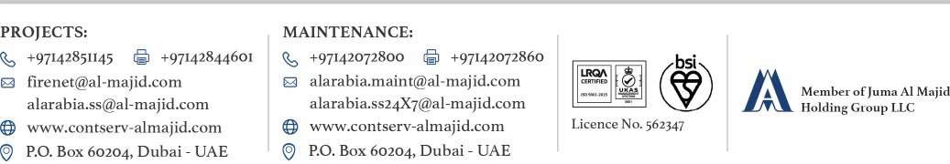

DRAFT WARRANTY FOR FIRE ALARM & VOICE EVACUATION SYSTEM
DATE: 16/06/2025
REF NO.: LTR/2028/MR/25
SUBJECT: DRAFT FIRE ALARM & VOICE EVACUATION SYSTEM WARRANTY CERTIFICATE
PROJECT: Samana IVY Garden-2 (1B+G+4P+35+Roof) Residential Building

CLIENT: M/s. Samana IFM Holding Ltd

CONSULTANT: M/s. Al Hilal Engineering Consultant
CONTRACTOR: M/s. ITALTECH CONTRACTING L.L.C
MEP CONTRACTOR : M/s. ITALTECH CONTRACTING L.L.C
Dear Sir,

We the under-sign M/S. AL ARABIA FOR SAFETY & SECURITY LLC
P O BOX 60204 Dubai U.A.E
This is to certify that all fire alarm system materials manufactured & supplied by M/s. EDWARDS are warranted in the above project for a period of TWO YEARS from TOC subject to the following terms and conditions.

- This warranty shall cover all the manufacturing defects where failure has been caused by faulty materials or workmanship and shall not cover other damage or defect shows ever caused.
- It shall be client/ operator responsibility to notify us of any defects appearing in our system immediately on occurrence.
- During the Defect liability period DLP this warranty shall be void if the system is maintained by a party other than the supplier (Al Arabia for Safety & Security L.L.C).
- This warranty is interpreted according to the laws of United Arab Emirates.

For Al Arabia for Safety & Security LLC

